**Name**: Khushei Meghana Meda

**SRN**: PES1201800416

**Week number**: 8

**Name of experiment**: IPv4 Static Addressing and Routing

**Date**: 08-11-2020

**Objectives of the experiment**: Understand the building blocks and usage of ClayNet Network Virtualization platform with reference to OSI Layer.

**Topology 1:**

Topology-

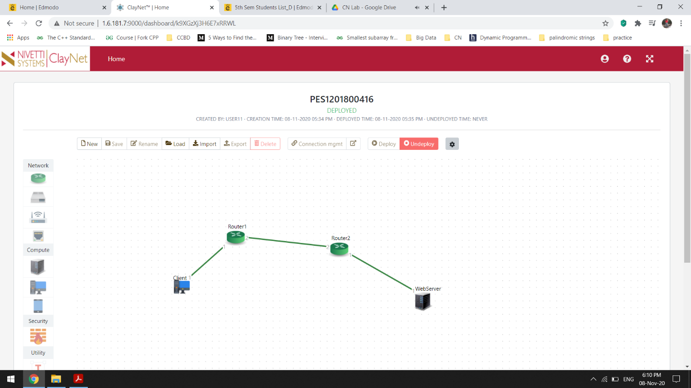

Pinging-

Web server-

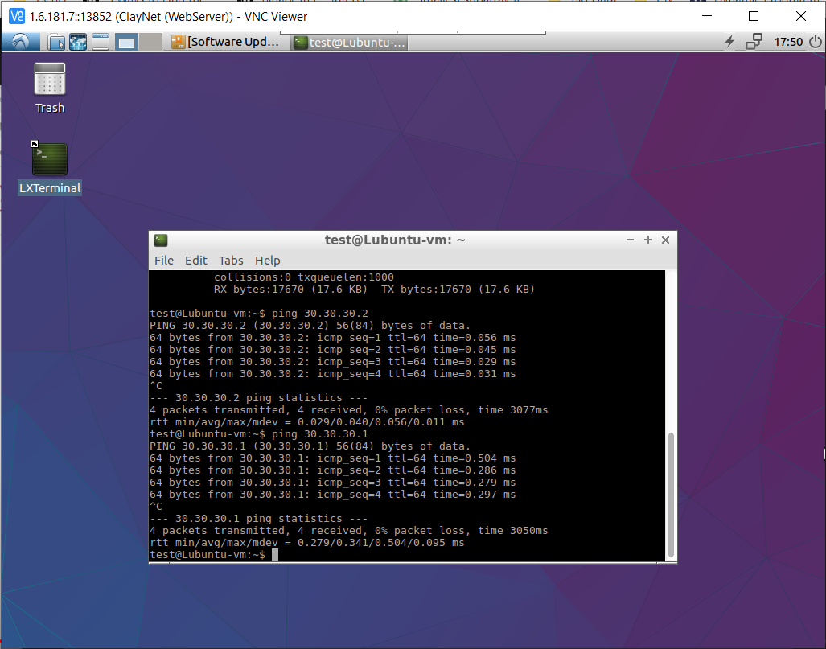

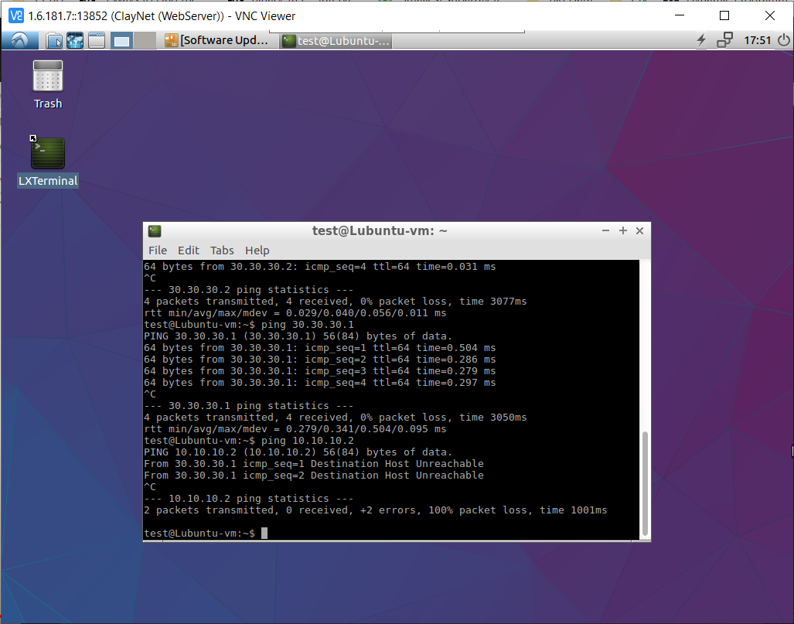

Client-

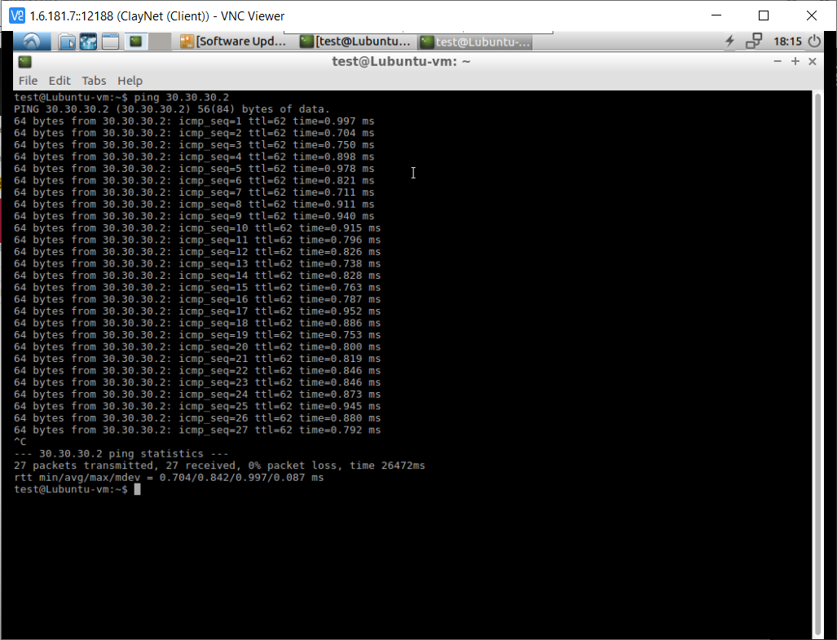

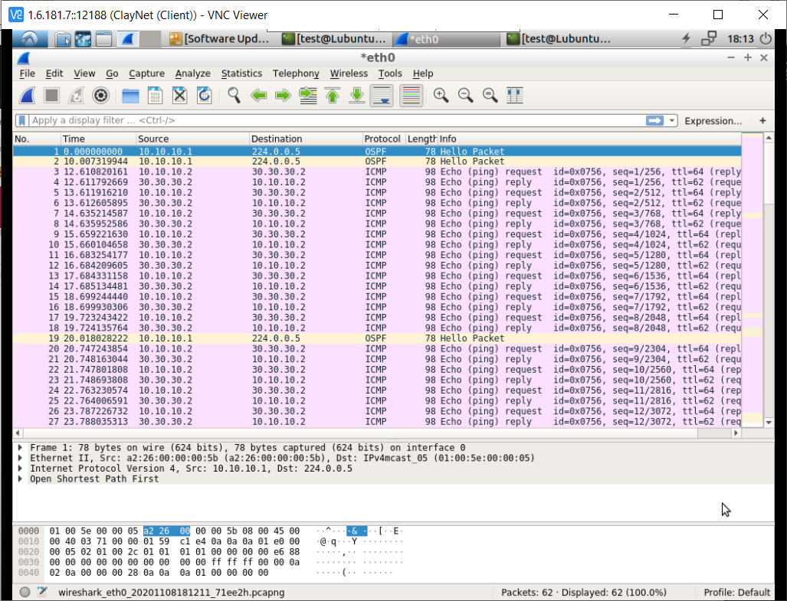

Observations:

• How many hops will client take to reach the server?

It takes three hops.

• Observe the RTT and justify your observation.

0.842 ms is the average RTT. The number of hops are few, hence the RTT is also low.

• While pinging, cut the link between Router1 and Router3. What will happen now?

We get a message saying ‘Destination host unreachable’.

